SL NO. | NAME OF PROGRAME | REPORT OF PROGRAME | PHOTOGRAPHS
 | Digital Generation | IIIrd year BSC Nursing students (Department of Child Health Nursing) of Al Shifa  College of nursing celebrated International Day of the Girl child on 27-11-2021. The  programme was based on the theme "Digital Generation". Venue of the programme was A-  Shifa college of nursing auditorium and the programme was inaugurated by Prof. Dr.  Muhammed Yahiya (medical superintendent KIMS Al Shifa Hospital), Principal DR. G  Thilagavathy Roy, Vice principal Prof. Sini Neeruzhi, HODs of various departments,  Teaching and Non teaching staff were present at the time of inaugural function. All the BSc  and post BSc students attended the programme. Short film was prepared by IIIrd year BSc  nursing students besed on the theme of international girl Child Day. The title of the short film  was "Alice the Elegant"- chasing the dream. Short film was release by Prof. Dr. Muhammed  Yahiya (medical superintendent KIMS Al Shifa Hospital) on 27- 11- 21 at 3 PM. The  programme was ended with national anthem. | 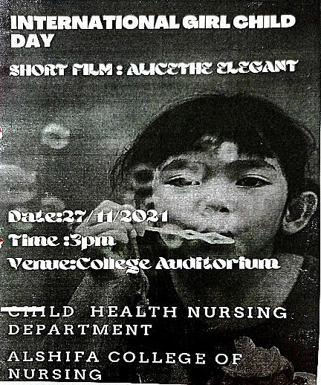  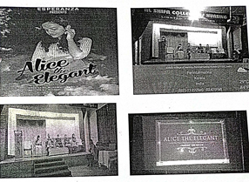
 | Women’s day celebration | The International Women's Day is observed on March 8th every  year. This year, the women cell of Al Shifa College of Nursing  organized a webinar through online platform the google meet in  connection with the observation of International women's day on the  topic "Women Empowerment".  The webinar was conducted on 8th March 2021 at 3.00-  4.00PM. in the inaugural session,women cell coordinator MS.Anjali.C  welcomed the participants of the programme. Presidential address was  done by Principal Dr.G.Thilagavathy Roy .The cheif guest of the  webinar was ADV.INDIRA.A.V. she emphasized the importance of  women empowerment in the current society.  All the students and teachers were the audience of the  webinar. After the session on women empowerment, Prof.Sini  Neeruzhi, Vice principal, Al Shifa college of Nursing delivered the  vote of thanks and the memento of honour was presented to the chief  guest by Dr.G.Thilagavathy roy.The programmed was concluded by  4.00pm | 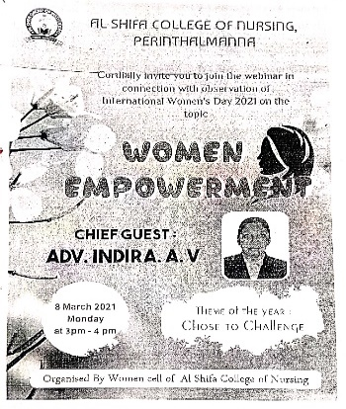
 | International day for the elimination of  sexual violence in conflict | The United Nations observe June 19th of every year as international day for the  elimination of sexual violence in conflict from 2015. The Obstetrics and  Gynaecological nursing department of Alshifa College of Nursing, Perinthalmanna  decided to conduct various competitions for the students as a part of observing  international day for the elimination of sexual violence in conflict.  Brochure and rules and regulations were prepared and discussed in department  in online mode. After finalizing, they were intimated in the online staff meeting and  also forwarded to the concerned class coordinators. As per the Principal's instruction,  first year BSc nursing students were exempted from the participation. The  competitions were Elocution [English] competition, story writing [Malayalam]  competition and Poster making competition. The evaluators for Elocution competition  were Mr. Jansan Mathew and Ms. Deepa V. The evaluators for poster making  competition were Ms. Sasikala A and Mr. Prasanth. For story writing, Ms. Vandana  and Ms. Rincy Alex were the evaluators. On 19th June 2021, the competitions were  completed and results were obtained.  In Elocution [English] competition, Ms. Nasrin Shibu, 3rd year BSc nursing,  secured first place and Ms. Beula Raj, 4th year BSc nursing got 2nd place. In story  writing [Malayalam] competition, first place was secured by Ms. Sarangi K, 2nd year  BSc nursing, second place by Ms.Farisha, 4th year BSc nursing, and third place by Ms.  Sinsha, 1 year MSc nursing. In poster making competition, Ms. Sinsha, 1" year MSc  nursing got the first place, Ms. Gopika Gopi, 2nd year PBBSc nursing got second  place and Ms. Gargi M P, 1st year MSc nursing got third place. | 
 | WORLD BREAST FEEDING WEEK CELEBRATION | Every year we celebrate august first week as breast feeding week. This year the  department of Obstetrics and Gynaecological nursing and Child Health Nursing in coordination  with National Service Scheme had celebrated the breastfeeding week from 1 to 7 August with  the theme of Protect Breastfeeding: A Shared Responsibility. The programmes planned were  e poster making competition, video making and pamphlet distribution.  E poster making competition was conducted on 28/7/21 among students. The winner of  the competition was Ms. Sinsha K, First year M.Sc. Nursing.  A video on importance and benefits of breast feeding was prepared by the first year  P.B.BSc. Nursing students with a view to give awareness to the common people through the  social media.  Around 200 pamphlets were distributed on 5/8/22 by the first year P.B.BSc. students at  the bus stand, Perinthalmanna town. The pamphlets includes information regarding techniques  and importance of breast feeding.  The overall programme was successful. Based on the theme we could highlights the link  between breastfeeding and survival, health and wellbeing of the women, children and nations. | 