SL NO. | NAME OF PROGRAME | REPORT OF PROGRAME | PHOTOGRAPHS
1. | International  women’s day - JANANI | International Women's Day is a global day celebrating the social,economic, cultural and political achievements of women. The day also marks a call to action for accelerating gender parity. Significant activity is witnessed worldwide as groups come together to celebrate women's achievements or rally for women's equality.  International Women's Day was celebrated at AI Shifa College of nursing on 8th March, 2022. Women Development Cell and National Service Scheme coordinately organized a dashing programme, dedicated to the loving women around them. The theme of this year was "Gender equity today for a sustainable tomorrow". Based on this we organized a programme Janani". The  purpose of celebrating Women's Day is - To raise awareness about the status  and dignity of women among the students.  On the day of celebration, from 8 am onwards the NSS Volunteers have entrusted at reception area in front of the college campus and distributed  around 400 greeting cards with chocolates.  The official programmes were started from 2pm on wards with a prayer song. Mrs Sheeba S (Asst. Professor & women development cell coordinator  (Al Shifa College of nursing) welcomed the gathering. The program was inaugurated by head of the institution followed by an inspiring speech about Women Empowerment. Student representatives highlighted the significance of the day, they described the plight of women at present through an elaborated speech. A video tribute played about mile stones of successful women which was highly inspiring and boost the self-confidence of each women and a film (Dhangal)show organized which conveyed an inspiring message to the women of this generation to be women of courage, compassion and care at the same time not forgetting to be a self-reliant and an independent woman. | 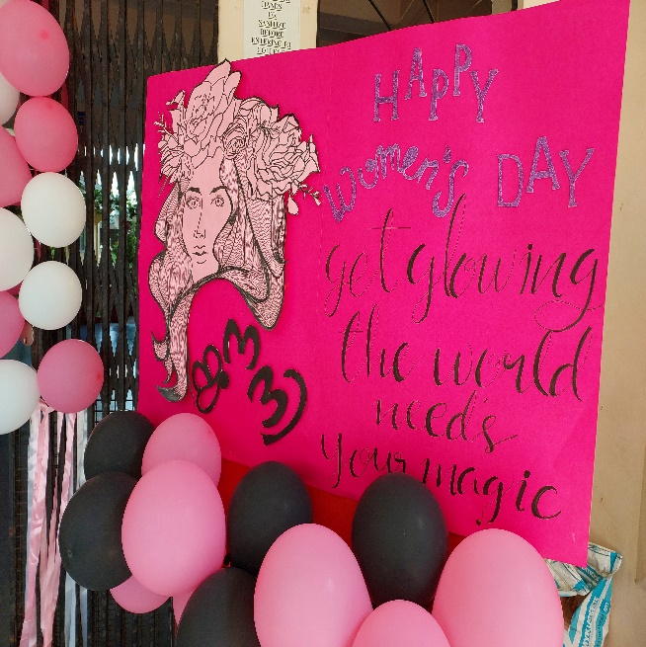  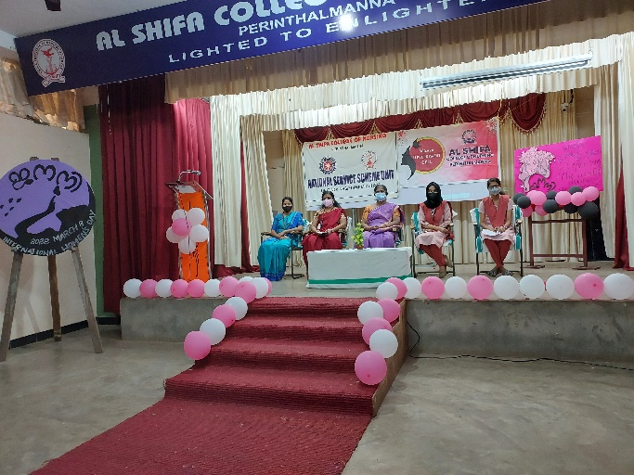  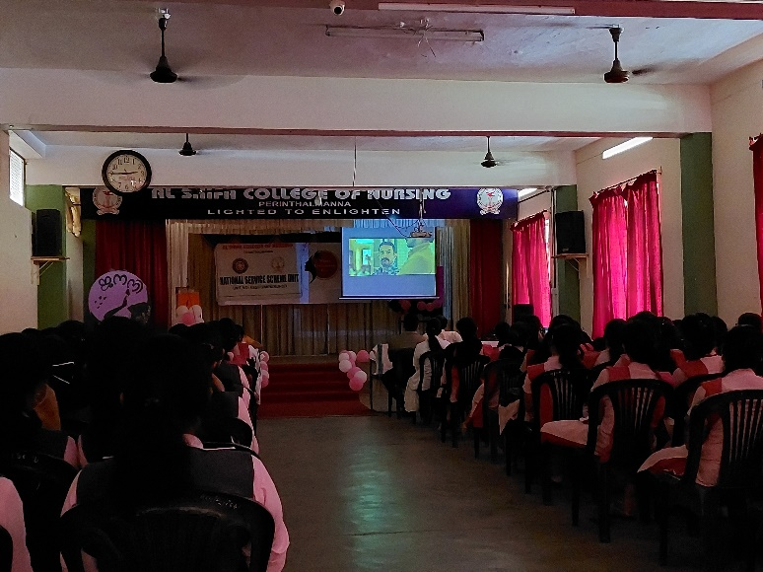
2. | Antiragging | Al Shifa College of Nursing has organized awareness on Anti ragging programme in  association with Anti Ragging Committee On 21.04.2022 At Al Shifa Auditorium from 9 Am till 1PM. The Speaker was Mr.Anish Chacko, Senior Police Officer Manjeri Police Station.The First session of the workshop involved the topic of various cyber-crimes, prevalent in the society. With examples of shocking news reports and statistics charts which showed alarming rise in crimes. The speaker explained the various types of cyber-crimes which were commonly committed. The talk dealt with detailed explanations of various issues like ID hacking. E-commerce cheating, Mobile abuse, subscription fraud, fake relationships through social medias, cyber bullying and cyber stalking. Quoting the anecdotes of various victims of cybercrimes, he emphasized the need to remain vigilant and to hold back from entertaining criminal thoughts in mind among the students. The students were made to say a pledge, making a vow to never indulge in activities which could be potentially dangerous to another  person or society.  The Second session of the talk dealt with the serious issue of ragging. He quoted the Kerala Prohibition act of ragging and outlined the serious repercussions of ragging. Students were made aware of the various sections of law that dealt with the different types of ragging. Mr.Anish Chacko stressed on the need to maintain a collective responsibility to ensure a peace full  atmosphere for all the students of an institution. Th students were provided with official email IDs and were encouraged to bravely report any instances of offensive behavior.  The talk also included the gradual deterioration of a person, prone to internet and mobile addiction. along with video clippings, showing addicted teens, to underline the seriousness of the issue.  After displaying the various sections of IT act dealing with cyber-crimes, the workshop  concluded with an inspiring thought-"the purpose of technology is to elevate man'.  The session was ended by 1PM. | 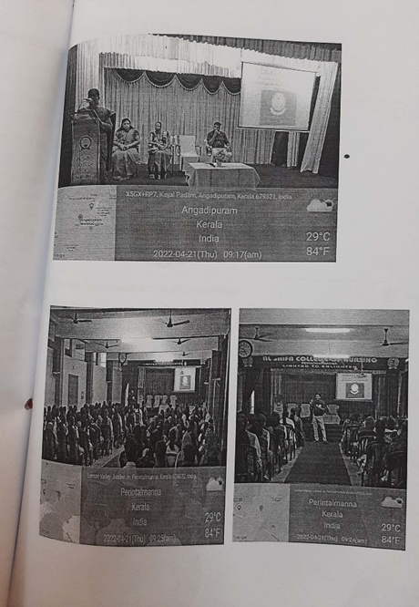
3 | Breast feeding week observance | Every year Al shifa college of Nursing celebrates world breast feeding week observance on first  week of August. This year Breast feeding week was celebrated from August 1 to 7 at KIMS Al Shifa Hospital and government hospital Perinthalmanna. The programme was coordinated by the Department of Obsterics and Gyceological Nursing. Child Health Nursing, Health Club.  Women Cell and National Service Scheme Unit. The theme of World breast feeding week 2022 is SET UP FOR BREASTFEEDING, EDUCATE AND SUPPORT. Based on this theme the students of Al Shila college of Nursing conducted Health Exhibition. Awareness classes, Skit  and Street Play.  KIMS AI Shifa Hospital  The world Breast feeding week observance 2022 held on KIMS Al Shifa Hospital on 2/8/22 at10.30am. The programme was started with welcoming all the dignitaries and the audience by Prof. Sini Neeruzhi (Vice Principal. AI Shifa College of Nursing). The programme was  inaugurated by Dr. P Uneen (Managing Trustee. Shifa Medicare Trust) and Presided by Prof.  Josephine Jacquline Mary N.I, Principal. Al Shifa College of Nursing). An awareness talk was  held by Dr. Moideen Babu Perayil (Consultant Neonatologist. KIMS Al Shifa Hospital Perinthalmanna. Dr Nayantara HOD Gynecology. KIMS Al Shifa Hospital. Perinthalmanna). Dr. valsa B Gcorge(Consultant Obstetrics & Gynecologist. KIMS AI Shifa Hospital. Perintahlmama) Dr. Saitha P.SConsultant Obstetrics & Gynecologist. KIMS AI Shifa  Hospital.Perintahlmann) Dr. Amina Noushad (Gynecologist. KIMS AI Shifa Hospital. Perinthalmanna).  Dr Vipin kalathil (Paediatrician. KIMS Al Shifa Hospital Perinthalmanna) Delivered a warm felicitation for the grant success of the programme. The gathering was thanked by Mrs. Rincy Alex, Asso. Prof, Obstetrical & Gynecological nursing. Al Shifa College of Nursing.  GOVERNMENT HOSPITAL PERITHALMANNA  The world Breast feeding week observance 2022 held on Government Hospital on 5/8/22 at10.30am. The programme was started with welcoming all the dignitaries and the audience by Mrs. Shinu Xavier Nursing tutor, Al Shifa College of Nursing). The programme was inaugurated by Dr Bindu C (Gynecologist. District Hospital. Perinthalmanna) and Presided by Prof.Josephine jacquline Mary NI, Principal. Al Shila College of Nursing). An awareness talk was  held by Dr. Biju Thaiyil (Pediatrician. District hospital. Perinthalmanna RMO (District Hospital, Perinthalnanna). Prof Sini Neeruzhi  (Vice Principal. Al Shifa College of Nursing).  NSO District Hospital. Perinthalmanna) delivered a warm felicitation for the grant success of  the programme. The gathering was thanked by Latha K (Public Health Nurse I/C). At the conclusion of the programme. 3rd year and 4th year students presented skit and street play which was really informative.  A health talk on importance and | benefits of breast feeding was prepared by Ms. Anila (1st year  MSC (N) student with a view to give awareness to the public. Around I50 feedback forms were  distributed on 2/8/22 and 5/8/22 by the first year P.B.BSc. students. Feedback analysis of breast  feeding week observance from KIMS Al Shifa Hospital shows 70% excellence and in  Government hospital shows 81% of excellence. 3rd year bsc, 4th year bsc and 1st year pcbsc  nursing students organized health exhibition which covers all the aspects of Theme. importance  and preparation of mother for breast feeding, signs of good attachment. position and physiology of lactation. types and composition of milk. contra indication & indication of artificial feeding, procedure of artificial feeding. working mothers and feeding. diet which increase breast milk.  The overall programme was successful and worth to the public. Based on the theme we could  highlight the link between breastfeeding and survival. health and wellbeing of both women and  children. | 