SL NO. | NAME OF PROGRAME | REPORT OF PROGRAME | PHOTOGRAPHS
1. | International Women’s Day Celebration | International women’s Day is on Wednesday 8th March 2023. It is a global day celebrating the social, economic, cultural, and political achievements of women. A day to celebrate women's  achievements, raise awareness on gender discrimination, and drive gender parity initiatives. This year's theme is DigitALL: Innovation and technology for gender equality highlights the role  Women's innovative technology in promoting gender equality and meeting the health and developmental needs of women and girls. Innovations have equally enhanced capacity building and knowledge translation through online training, webinars, and innovative tools for patient  care such as telemedicine, robotics, and artificial intelligence.  As a part of Women's day celebration Women Development Cell, NSS, IQAC & Innovation cell organized Various activities at Al Shifa college of nursing Campus named "AVYANNA".  On the day program started with prayer song by college coir. Mrs Josephinen Jacquline Mary NI, Principal, Al Shifa College of Nursing delivered welcome address. The program was Presided by Mr Suhail Harnza P, General Manager, Shifa Medicare Trust. The program was  inaugurated by Adv.Najma Thabsheera, standing committee chairperson women welfare, Perinthaimanna block and she rendered a motivational talk on Women Empowermnent. Workshop on "VEDIO EDITING" was done by Mr.Umer Mugthar & Muhammed Aslam students from Majilis college of Art & Science, Valancherry. A gender-responsive approach to innovation, technology and digital education can increase the awareness of women and girls  their rights and civic engagement. Advancements in digital technology offer immense oppourtunities to address development and humanitarian challenges as a part of this we organized the  launching ceremony of online women entrepreneurship platform "SHIFFA MART" to empower women of Alshifa college of Nursing also launched counselling App "HEED & HEAL" to  enliate thc problems faced by the students As a part of women empowerment we signed an MOU with "KVR MARUTI" Driving School in which the students and other female staff can utilize benefit of their service for a colorful future.The end, Mrs Sheeba S. Assistant Professor, Al Shifa College of Nursing, delivered Vote of  thanks, and the program was concluded with a feedback session. | 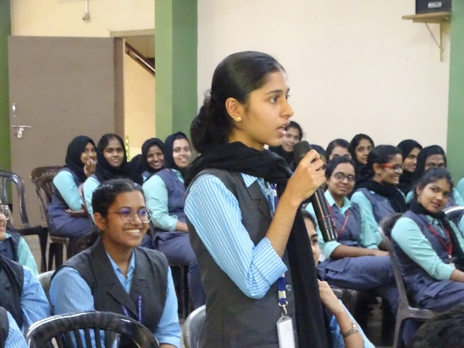  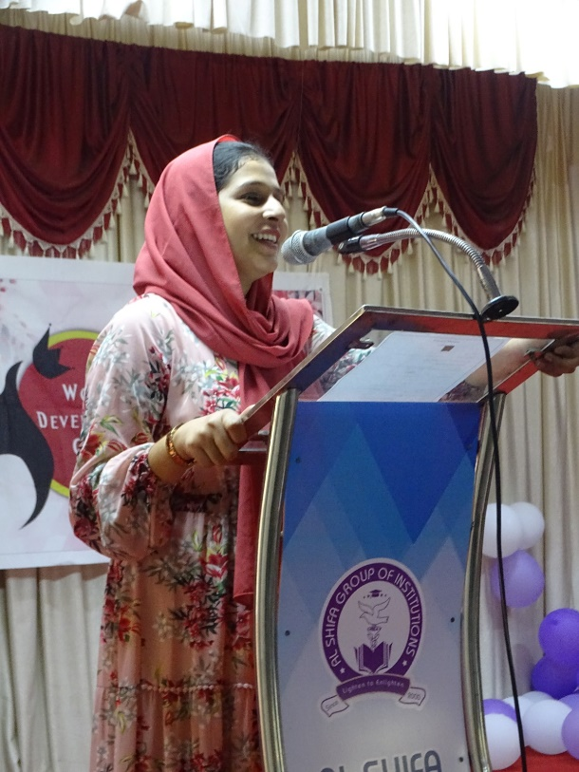  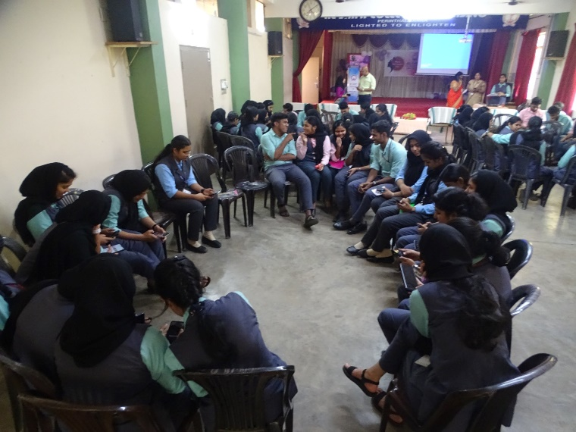  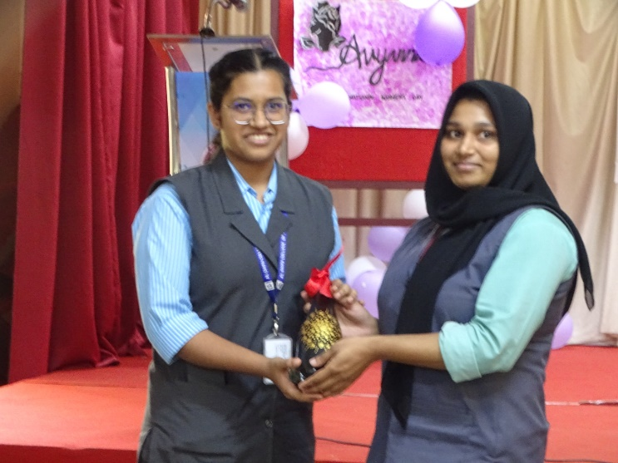
2. | MOU signing ceremony | Al shifa College of Nursing signed an MOU with KVR Maruti driving school on 8th March 2023 to enhance the driving skill and knowledge of students and faculties. Both parties' intent to cooperate and focus their efforts on knowledge upgradation and skill enhancement in driving to empower the  Raieev C, MSDS Manager, KVR Maruti driving school, Perinthalmanna were the signatories.  Ms Josephine Jacquelin Mary N.I. Prinicipal, Al Shifa College of Nursing and Mr Bijith Nelson, General Manager of KVR Maruti driving school were signed as witness. Mr Suhail Hamza P,addressed the gathering with the background of the two institution and the purpose of signing the  MOU which is to have a long-term cooperative relationship and collaboration between both institutions. Mrs Sini Neeruzhi, Vice Principal thanks the manager of KVR Maruti driving school for taking initiative for joining hands with Al Shifa College of Nursing. | 